FLOATING MOON USING

COMPUTER GRAPHICS

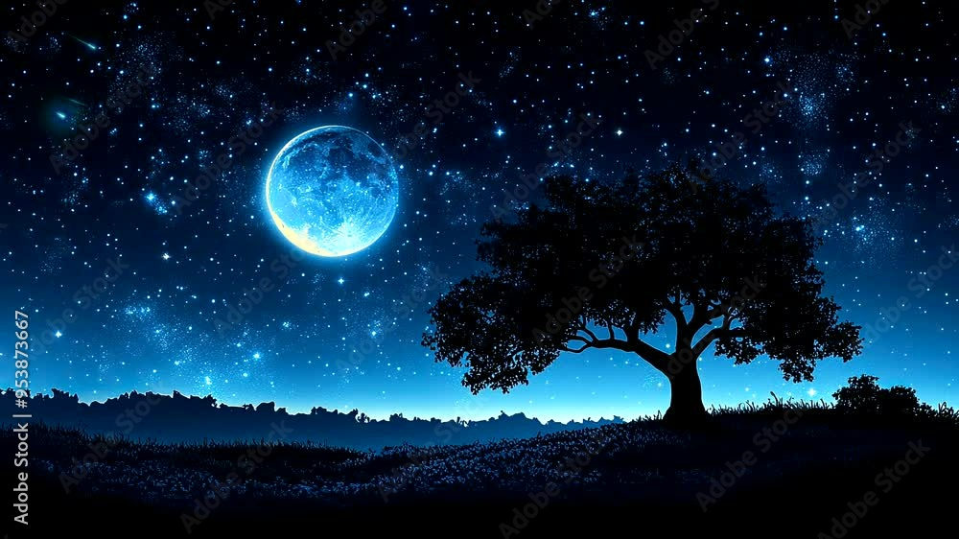

Department of Computer Engineering
Group Member:
1. Ayaan Shaikh (24111590810)

INDEX
1. Abstract
2. Introduction
3. History / Working
4. Program
5. Diagram
6. Application
7. Conclusion
8. References

ABSTRACT
The project “Floating Moon Using Computer Graphics” demonstrates the implementation of 2D animation and transformation techniques to simulate the gentle floating motion of a moon against a night sky filled with stars. Developed using the C programming language and the graphics.h library, the project applies concepts such as translation, rotation, and real-time rendering to create a realistic and visually appealing animation.
The animation includes elements like twinkling stars, a smoothly floating moon, and occasional shooting stars to enhance realism. It utilizes randomization and trigonometric functions to control object motion and visual variation. This project highlights how fundamental computer graphics principles can be used to simulate natural motion and celestial scenes effectively.
The “Floating Moon” simulation serves as an educational model to understand real-time animation control, coordinate transformation, and object movement synchronization. It bridges theoretical mathematics and visual design, encouraging creativity and analytical thinking among learners.
Keywords: Computer Graphics, Animation, Transformation, Stars, Moon Simulation, Real-Time Rendering.

1. INTRODUCTION
Computer Graphics enables the visualization of mathematical and logical concepts in a visually interactive manner. The project “Floating Moon Using Computer Graphics” aims to simulate a realistic night sky featuring a moving moon, twinkling stars, and a shooting star using simple graphics primitives in C.
This program demonstrates the concept of translation, where the moon continuously moves across the screen to mimic floating, and randomization, which governs the twinkling of stars and motion of shooting stars. The project highlights how graphical transformations can be applied to produce motion effects without the use of complex physics engines.
By executing this project, learners gain practical exposure to 2D transformations, frame refreshing, and real-time animation. It provides a creative yet structured approach to understanding object motion and scene rendering within the graphics library environment.

2. HISTORY / WORKING
The concept of simulating celestial objects dates back to early computer graphics studies where basic geometric transformations were used to animate natural scenes. The “Floating Moon” project extends this concept by combining translation, randomization, and frame-based animation to simulate a night sky.
Working Principle:
1. Initialize the graphics mode and set the background color to black.
2. Randomly generate stars with twinkling behavior.
3. Draw and animate a moon moving smoothly across the screen.
4. Introduce shooting stars that appear randomly.
5. Refresh each frame by clearing the screen and redrawing elements with updated positions.
This loop continues indefinitely until a key is pressed, producing a smooth floating effect for the moon and dynamic twinkling for the stars.

3. OUTPUT OF THE PROGRAM

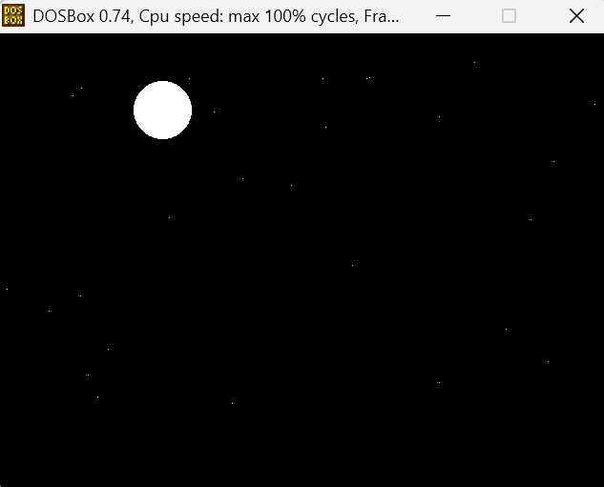

3. PROGRAM
#include <graphics.h>
#include <conio.h>
#include <stdlib.h>
#include <dos.h>
#include <math.h>
#include <time.h>
#define MAX_STARS 50
#define PI 3.14159265
typedef struct {
int x, y;
int twinkle; // 0 or 1
} Star;
typedef struct {
int x, y;
int active; // 0=inactive, 1=active
} ShootingStar;
// Initialize stars randomly
void initStars(Star stars[]) {
int i;
for (i = 0; i < MAX_STARS; i++) {
stars[i].x = rand() % getmaxx();
stars[i].y = rand() % (getmaxy() - 50);
stars[i].twinkle = rand() % 2;
}
}

// Draw stars
void drawStars(Star stars[]) {
int i;
for (i = 0; i < MAX_STARS; i++) {
if (stars[i].twinkle) {
putpixel(stars[i].x, stars[i].y, WHITE);
}
}
}
// Update stars for twinkling
void updateStars(Star stars[]) {
int i;
for (i = 0; i < MAX_STARS; i++) {
stars[i].twinkle = rand() % 2;
}
}
// Draw moon
void drawMoon(int x, int y) {
setcolor(WHITE);
setfillstyle(SOLID_FILL, WHITE);
circle(x, y, 30);
floodfill(x, y, WHITE);
}
// Initialize shooting star
void initShootingStar(ShootingStar *s) {
s->x = rand() % (getmaxx() - 100);
s->y = rand() % (getmaxy() / 2);
s->active = 1;
}
// Draw shooting star
void drawShootingStar(ShootingStar *s) {
if (s->active) {
setcolor(WHITE);
line(s->x, s->y, s->x + 10, s->y + 10);
}
}
// Update shooting star
void updateShootingStar(ShootingStar *s) {
if (s->active) {
s->x += 5;
s->y += 5;
if (s->x > getmaxx() || s->y > getmaxy()) {
s->active = 0;
}
}
}
// ================== MAIN ==================
int main() {
int gd = DETECT, gm;
initgraph(&gd, &gm, "C:\\TURBOC3\\BGI");
srand(time(NULL));
setbkcolor(BLACK);
cleardevice();
Star stars[MAX_STARS];
ShootingStar sStar;
sStar.active = 0;

initStars(stars);
int moonX = 50, moonY = 80;
double angle = 0; // satellite angle
int earthX = getmaxx()/2, earthY = getmaxy() - 100;
int earthRadius = 50;
int satRadius = 10;
int orbitRadius = 80; // distance of satellite from Earth
while (!kbhit()) {
cleardevice();
// Draw stars
updateStars(stars);
drawStars(stars);
// Draw Moon
drawMoon(moonX, moonY);
moonX += 1;
if (moonX > getmaxx() + 30) moonX = -30;
// Shooting star
if (!sStar.active && rand() % 50 == 0) {
initShootingStar(&sStar);
}
drawShootingStar(&sStar);
updateShootingStar(&sStar);
// Draw Earth
setcolor(BLUE);
setfillstyle(SOLID_FILL, BLUE);
circle(earthX, earthY, earthRadius);
floodfill(earthX, earthY, BLUE);

// Draw Satellite orbiting Earth
int satX = earthX + orbitRadius * cos(angle);
int satY = earthY + orbitRadius * sin(angle);
setcolor(WHITE);
setfillstyle(SOLID_FILL, WHITE);
circle(satX, satY, satRadius);
floodfill(satX, satY, WHITE);
// Update satellite angle
angle += 0.05;
if (angle > 2*PI) angle -= 2*PI;
delay(80);
}
getch();
closegraph();
return 0;
}

4. DIAGRAM
This project does not involve an electrical circuit diagram. Instead, it includes a visual simulation of a night sky composed of the following elements:
- A floating moon moving horizontally across the screen.
- Randomly twinkling stars scattered across the sky.
- A shooting star occasionally streaking diagonally.
- A static Earth near the bottom with an orbiting satellite.
These graphical components work together to create an animated celestial scene that closely resembles the natural motion of objects in the night sky.

5. APPLICATIONS
1. Used as an educational tool to demonstrate 2D graphics concepts.
2. Enhances understanding of animation principles and frame control.
3. Serves as a base for developing advanced space simulation games.
4. Demonstrates randomization and motion control in real-time.
5. Useful for creative visualization and multimedia applications.

6. CONCLUSION
The project “Floating Moon Using Computer Graphics” effectively visualizes a dynamic and serene night sky through programming logic and mathematical computation. By simulating the motion of a moon, twinkling stars, and shooting stars, it demonstrates key principles of computer graphics such as coordinate transformation, animation timing, and rendering optimization.
This project serves as a creative example of how basic programming can produce visually engaging simulations that enhance understanding of both technical and aesthetic aspects of computer graphics.

7. REFERENCES
1. Donald Hearn and M. Pauline Baker, Computer Graphics, C Version, Pearson Education.
2. Foley, J. D., van Dam, A., Feiner, S. K., & Hughes, J. F. (1995). Computer Graphics: Principles and Practice.
3. https://www.geeksforgeeks.org/computer-graphics-animation/
4. https://www.tutorialspoint.com/computer_graphics/2d_transformation.htm
5. Program implementation and design by Ayaan Shaikh (24111590810).

